**EXPERIMENT-1**

**AIM**: (i) To determine the acceleration due to gravity (g) by means of a compound pendulum.

(ii) To determine radius of gyration about an axis through the center of gravity for the compound pendulum.

**APPARATUS:** (i) A bar pendulum, (ii) a knife–edge with a platform, (iii) a sprit level, (iv) a precision stop watch, (v) a meter scale

**THEORY:** If the bar be allowed to oscillate about horizontal knife edge passing in each of the holes in turn, beginning with the nearest to center of gravity, and a graph plotted taking time period of oscillations as ordinates and corresponding distances of the axis of suspension from the end of the bar as abscissa, the graph will consist of two symmetrical branches.

**FORMULA USED:**

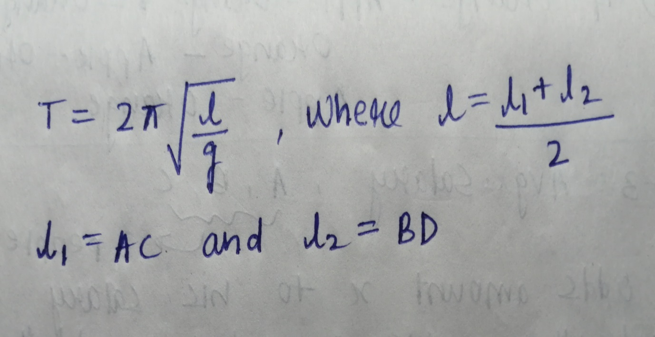

**OBSERVATION:**

|  |  |  |  |
| --- | --- | --- | --- |
| Number of holes from center | Distance from COG (in cm) | Time (for 10 oscillations in seconds) | Time Period (in seconds) |
| 1 | 5 | 25.16 | 2.516 |
| 2 | 10 | 18.87 | 1.887 |
| 3 | 15 | 16.42 | 1.642 |
| 4 | 20 | 15.30 | 1.530 |
| 5 | 25 | 15.28 | 1.528 |
| 6 | 30 | 15.02 | 1.502 |
| 7 | 35 | 15.20 | 1.520 |
| 8 | 40 | 15.40 | 1.540 |
| 9 | 45 | 16.10 | 1.610 |

For Inverted Pendulum:

|  |  |  |  |
| --- | --- | --- | --- |
| Number of holes from center | Distance from COG (in cm) | Time (for 10 oscillations in seconds) | Time Period (in seconds) |
| 1 | 5 | 25.88 | 2.588 |
| 2 | 10 | 18.90 | 1.890 |
| 3 | 15 | 15.34 | 1.534 |
| 4 | 20 | 15.18 | 1.518 |
| 5 | 25 | 15.10 | 1.510 |
| 6 | 30 | 15.20 | 1.520 |
| 7 | 35 | 15.34 | 1.534 |
| 8 | 40 | 15.97 | 1.597 |
| 9 | 45 | 16.13 | 1.613 |

**GRAPH:**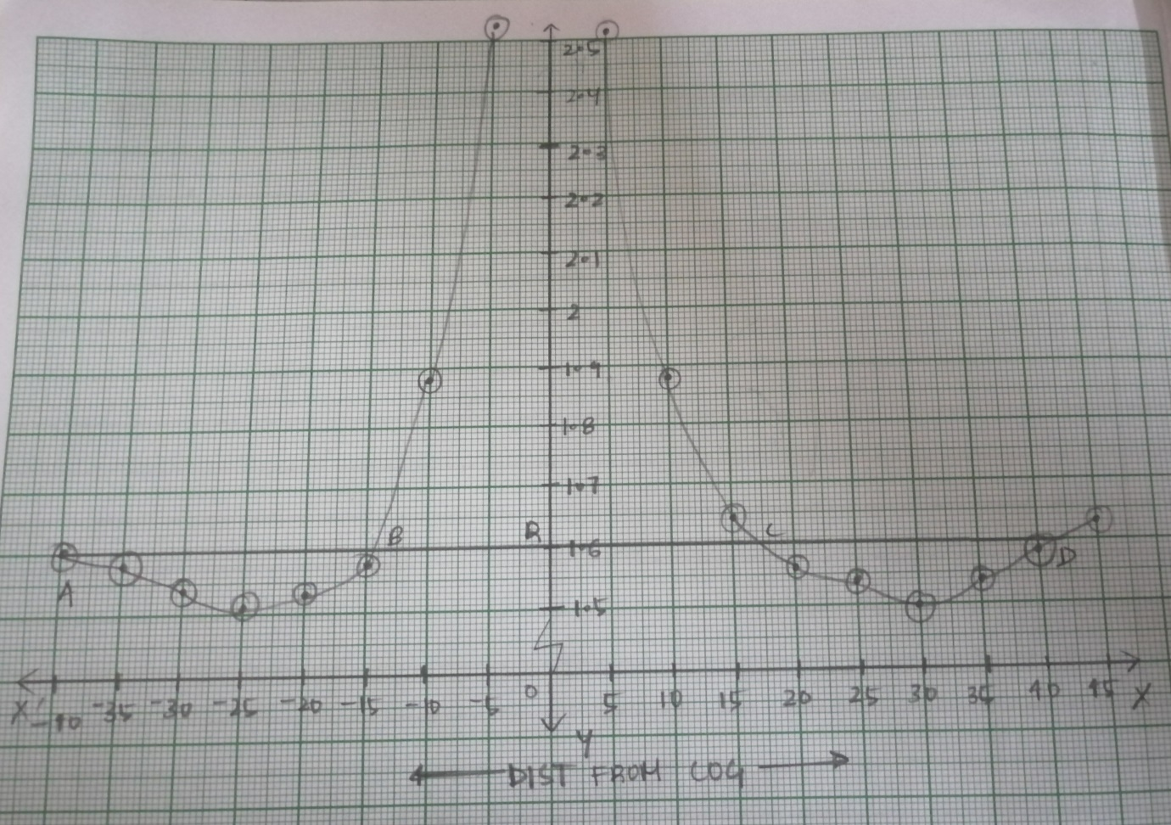

**CALCULATIONS:**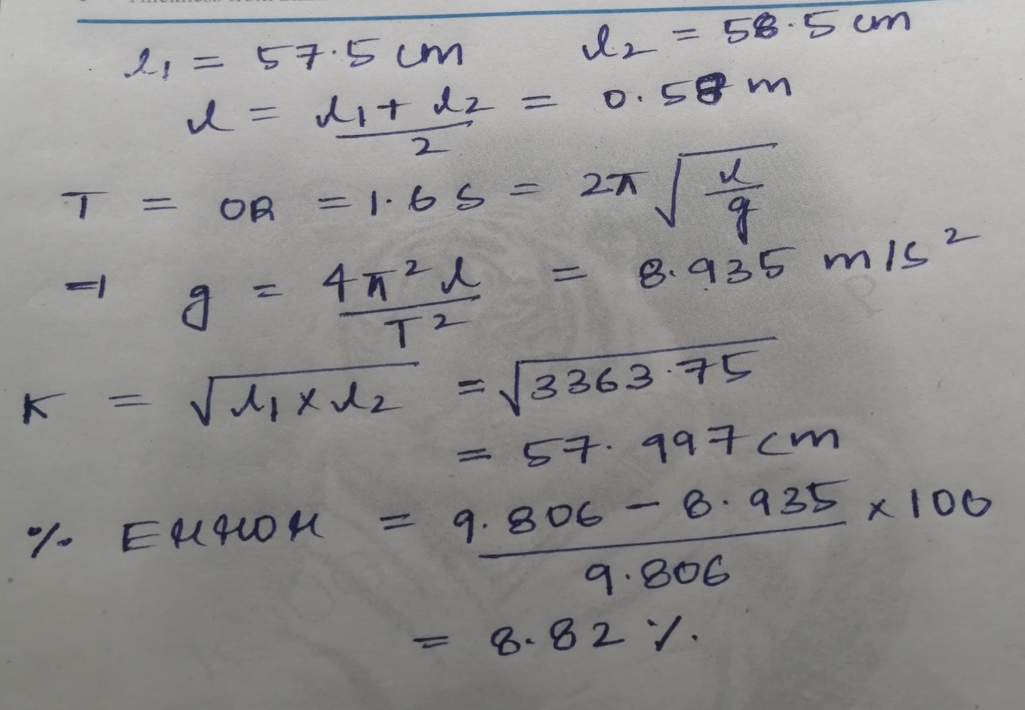

**RESULT:** 1) Acceleration due to gravity is 8.935 m/s2

2)Radius of gyration is 57.997cm

**SOURCES OF ERROR:**1) The knife edge may not be horizontal.

2)Air resistance could damp the oscillation.

3)Incorrect measurement of time.

4)Graph may be incorrectly plotted.

**By: Amogh Garg**

**2020UCO1688**

**COE(Section-3)**